4.

a)

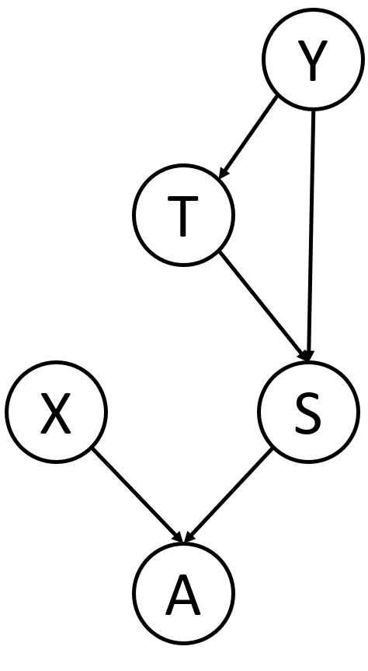

b)

|  |  |  |  |
| --- | --- | --- | --- |
| Machine Temperature = high | Sensor is Working | Sensor Reading = X | |
| X = high | X = low |
| T | T | α | 1- α |
| T | F | 1- β | β |
| F | T | 1- α | α |
| F | F | β | 1- β |

c)

|  |  |  |  |
| --- | --- | --- | --- |
| Sensor Reading = high | Alarm is Working | A sounds | |
| T | F |
| T | T | 1 | 0 |
| T | F | 0 | 1 |
| F | T | 0 | 1 |
| F | F | 0 | 1 |

5.

a)

A:

|  |  |  |
| --- | --- | --- |
| Zombie | S | |
| T | F |
| T | 7/10 | 3/10 |
| F | 12/20 | 8/20 |

B:

|  |  |  |  |
| --- | --- | --- | --- |
| N | B | S | |
| T | F |
| T | T | 4/6 | 2/6 |
| T | F | 8/11 | 3/11 |
| F | T | 4/5 | 1/5 |
| F | F | 3/8 | 5/8 |

bi)

A/B:

P(Zombie|N=T) = $\frac{P\left(Zombie\right)*P(N=T|Zombie)}{P(N=T)}$ = $\frac{\frac{10}{30}*\frac{7}{10}}{\frac{17}{30}}$ = 0.41176

bii)

A/B:

Knowing whether the person is a zombie, C and S are conditionally independent (Zombie is the parent of C, S is a non-descendent of C)

P(Zombie|C=T,S=T) = $\frac{P\left(Zombie\right)*P\left(C=T,S=T|Zombie\right)}{P\left(C=T,S=T,Zombie\right)+P\left(C=T,S=T|Human\right)}$

= $\frac{P\left(Zombie\right)*P(C=T|Zombie)*P(S=T|Zombie)}{P\left(Zombie\right)*P\left(C=T|Zombie\right)*P\left(S=T|Zombie\right)+P\left(Human\right)*P(C=T|Human)*P(S=T|Human)}$

= $\frac{\frac{10}{30}*\frac{6}{10}*\frac{7}{10}}{\frac{10}{30}*\frac{6}{30}*\frac{7}{30}+\frac{20}{30}*\frac{10}{20}*\frac{12}{20}}$ = 0.41176

biii)

A/B:

P(Zombie|B=F) = $\frac{P\left(Zombie\right)*P(B=F|Zombie)}{P(B=F)}$

= $\frac{\frac{10}{30}*\frac{1}{10}}{\frac{19}{30}}$ = 0.052631

c)

e = Zombie, N=T, C=T, S=T, B=F

P(A|e) = $\frac{P\left(A\right)*P(e|A)}{P(e)}$

P(B|e) = $\frac{P\left(B\right)*P(e|B)}{P(e)}$

Assuming P(A) = P(B), we need only compare P(e|A) and P(e|B)

P(e|A) = P(C=T, S=T, N=T, B=F, Zombie|A)

= P(C=T|S=T, N=T, B=F, Zombie)*P(S=T|N=T, B=F, Zombie)*

P(N=T|B=F, Zombie)*P(B=F|Zombie)*P(Zombie)

= P(C=T|Zombie)*P(S=T|Zombie)*P(N=T|Zombie)*P(B=F|Zombie)*P(Zombie)

= $\frac{6}{10}*\frac{7}{10}*\frac{7}{10}*\frac{1}{10}*\frac{10}{20}$

= 0.0098

P(e|B) = P(C=T, S=T, N=T, B=F, Zombie|B)

= P(C=T|S=T, N=T, B=F, Zombie)*P(S=T|N=T, B=F, Zombie)*

P(N=T|B=F, Zombie)*P(B=F|Zombie)*P(Zombie)

= P(C=T|Zombie)*P(S=T|N=T, B=F)*P(N=T|Zombie)*P(B=F|Zombie)*P(Zombie)

= $\frac{6}{10}*\frac{8}{11}*\frac{7}{10}*\frac{1}{10}*\frac{10}{30}$

= 0.010181

Since P(e|B) > P(e|A), it is better to choose B.